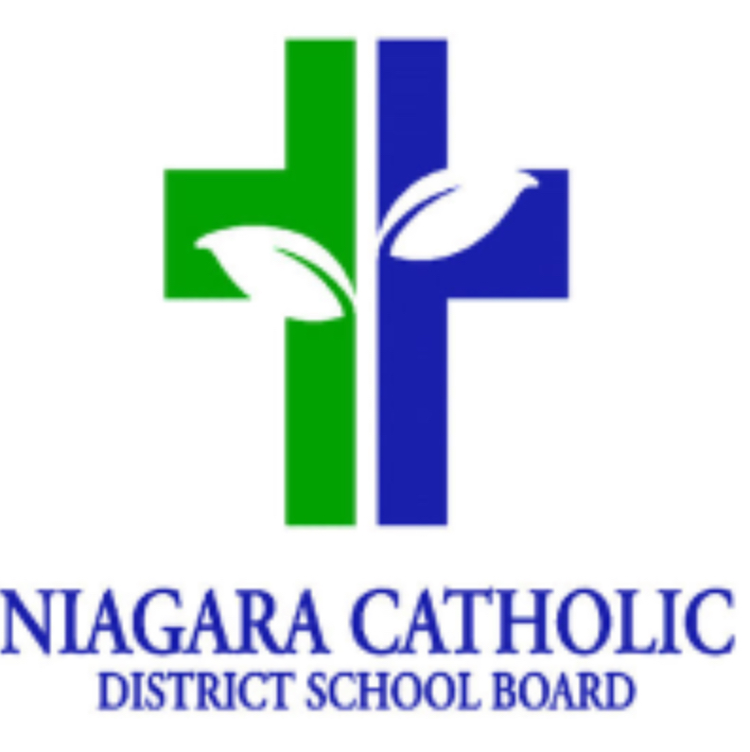

October 2024
St. Philomena Catholic
Faith Theme: We are Called
A member of the Lakeshore Catholic High School Family of Schools
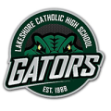
Sunday | Monday | Tuesday | Wednesday | Thursday | Friday | Saturday
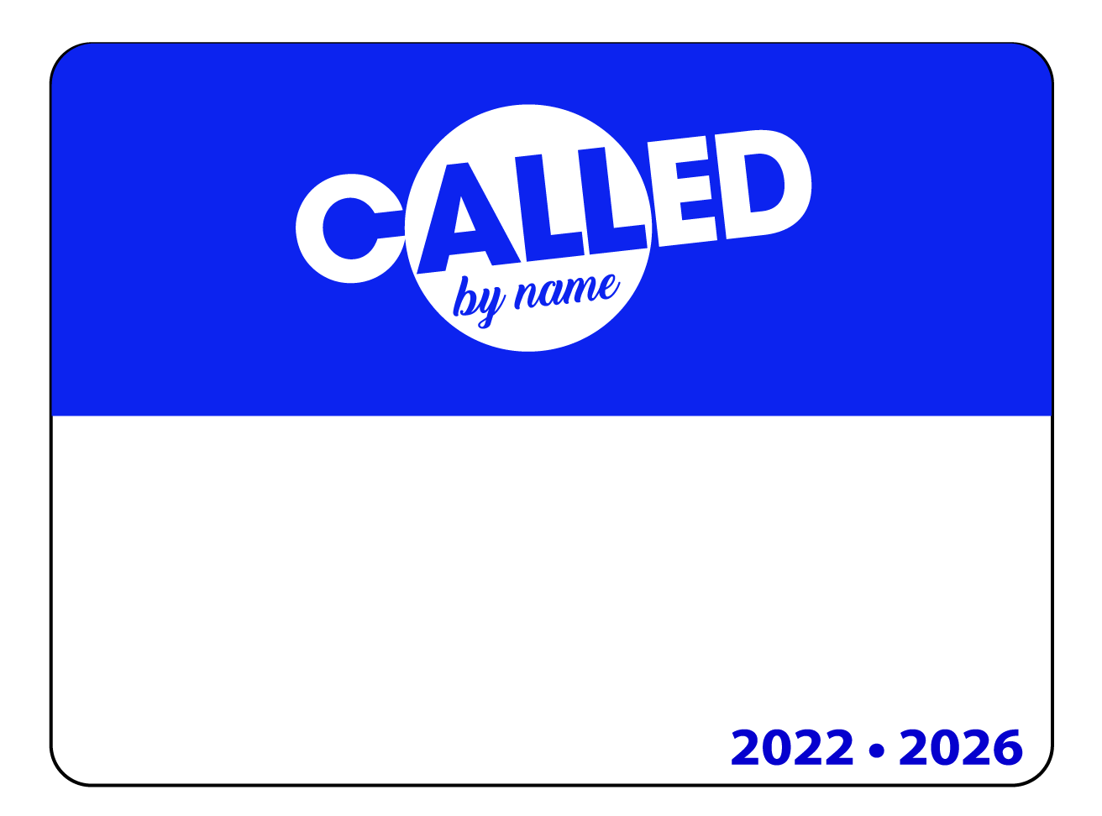 | Learning Disabilities Awareness Month  Canadian Library Month  SCO = School Cash Online | DAY 5 1  Fire Drill  Thanksgiving Food Drive Starts | DAY 1 2  Thanksgiving Mass - St. Michael’s Church 10:30am  Gr. 7/8 Girls Soccer Tournament  National Walk to School Day | DAY 2 3  Gr. 7/8 Boys Soccer Tournament  National Walk to School Day  Meet and Greet 5-6pm  Pizza Day | DAY 3 4  Terry Fox Online Donations Close | World 5  Teacher’s Day  Lunch Orders & Toonie Tuesday Open - SCO
6  Fire Safety Week | Day 4 7  Grade 7 Immunization Clinic  Firefighter Visit – JK/SK  CSC Meeting – 6:15pm | DAY 5 8  Gator Day – Gr 8’s | DAY 1 9  Gr. 7/8 Parent Meeting Winter Trip 5:30pm |   DAY 2 10  Pizza Day  Cross Country Meet Gr. 4-8  World Mental Health Day | 11  PD Day – No School  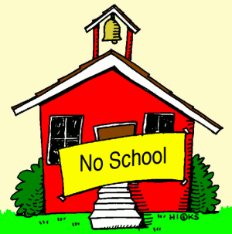  Gr. 7/8 Winter Trip  School Cash Deposit | 12
13 | 14  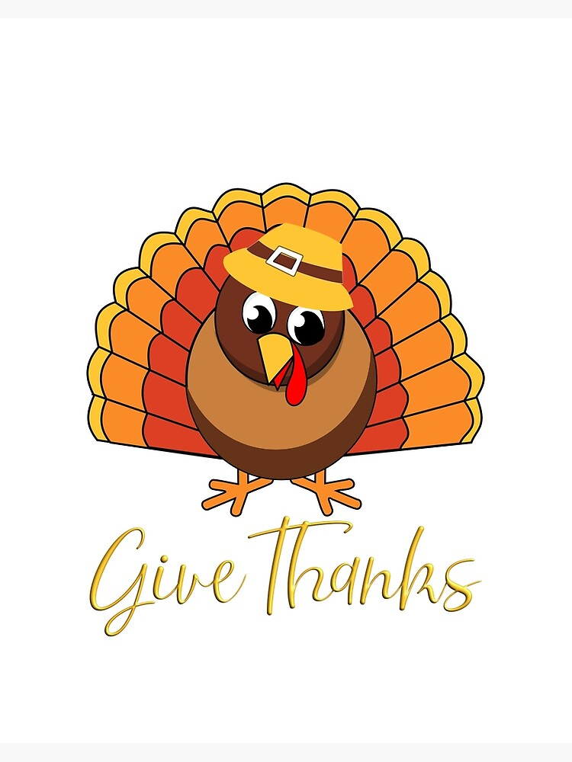  Happy Thanksgiving  No School | DAY 3 15  Big Box Fundraiser ends  IEPs Home | DAY 4 16  Sub Day  Lunch Orders & Toonie Tuesday Closes - SCO  Bus Driver Appreciation Day | DAY 5 17  Pizza Day | DAY 1 18  Librarian Appreciation Day | 19  Early Childhood Educator Appreciation Day
20  Walk, Bike, Roll to School Week | DAY 2 21  Lakeshore Visit @ STP | DAY 3 22    Board Cross Country  Picture Day |   DAY 4 23  Pita Day | DAY 5 24  Pizza Day  ECE and CYW Appreciation Day | DAY 1 25  Alternate Dress Day | 26
27 | DAY 2 28  Electrical Safety Presentations | DAY 3 29 | DAY 4 30 | DAY 5 31    Orange & Black Day  Pizza Day  Halloween Parade | Day 1 Nov 1 | Nov 2/Nov 3  Daylight Savings Time Ends Turn Clock Back 1 Hour
St. Michael’s Church Sunday 10am   |   Report all absences prior to 9:00am  Please use the toll-free number, the website, or the SchoolMessenger mobile app to report your child’s absence in advance. https://go.schoolmessenger.ca  The toll free number is: 1 844 287 6287 |  | Supervision: 9:00am School begins: 9:15am  Times  9:00-9:15 Morning Supervision  9:15-9:25 Morning Bell  10:05-10:20 Morning Recess  12:00-12:40 Lunch  1:40-1:55 Afternoon Recess  3:10 Kindergarten Dismissal  3:20 Kiss N Ride Dismissal  3:25 Dismissal |  | CONTACT INFORMATION  Principal: Mrs. A Cybula  1332 Phillips Street, Fort Erie, L2A 3C2  P: 905-871-1842  Email: st.philomena@ncdsb.com  Website: www.niagaracatholic.ca

